**Cloud computing**

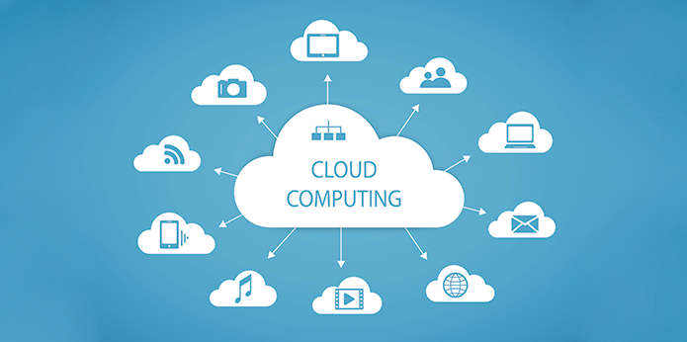

***Table of contents***

Introduction……………………………………………..……………..3

A brief history of cloud computing……………………………3

Benefits of cloud computing…………………………………….4

Features of cloud computing……………………………..……..6

Cloud Service Models……………………………………….………8

Companies dealing with cloud computing………………..10

Disadvantages of cloud computing…………………..………11

Conclusion……………………………….……………………………..11

References………………………………………………...……………12

***Introduction***

Cloud computingmeans, in short, to keep data, information, programs, and applications within a database, thus achieving higher speed and greater efficiency in addition to security and reducing costs, which leads to improved performance.

The provider of cloud computing maintains shared pools of the IT resources, and the resources are made available to the consumers as services over a network, such as the Internet or an intranet.

For the cloud consumers, the cloud is an abstraction of IT infrastructure from which they hire IT resources as services without the risks and costs associated with owning the resources. [2]

***A brief history of cloud computing***

As we all know, the computer began to appear in the fifties of the last century, and it was of a very huge size, and due to its small number and the multiplicity of its users, in the sixties, work began to share time between users to exploit the processor as much as possible, and this was the beginning of the birth of cloud computing, and more precisely in the year 1969, the first research appeared to link computers with Some of them are via the Internet, then work continued to develop this research in the seventies and eighties, and in 2006 Amazon launched computing services, and then Google, Microsoft and others.[2]

***The benefits of cloud computing***

*The first benefit* is the possibility of accessing programs by connecting to the Internet and opening a browser or a special application, and this facilitates the process of exchanging files and data between users.

*The second benefit* is the ability to access files from different devices, for example, you can check your email using any mobile phone or computer.

Those two previous benefits can summarize as availability: Cloud computing has the ability to ensure resource availability at varying levels depending on the consumer’s policy and application priority.

*The third benefit* Computing provides storage spaces for users to save backup copies of their private files including photos, videos, etc.

*The fourth benefit* is cost savings for large companies and institutions. Instead of building information and technology management centers, it has become possible to rely on computing to ensure employee communication and accomplish what is required of them.[3]

In a traditional environment, resources are often acquired and dedicated to specific business applications. These practices frequently result in higher up-front costs, the creation of IT silos, the underutilization of resources, and an increase in energy consumption. Cloud computing enables consumers to hire any required IT resources based on pay-per-use or subscription pricing. This reduces a consumer’s IT capital expenditure (CAPEX) as investment is required only for the resources needed to access the cloud services. Thus, cloud adoption has the potential to lower the total cost of ownership (TCO) for a consumer.

*The fifth benefit* of computing is access to updated and upgraded versions of programs and software faster than the old methods. When a company develops a specific software, it uploads the upgraded version to the cloud and users can easily download it.

*The sixth benefit* of computing isBusiness continuity:It is possible for IT services to be rendered unavailable due to causes, such as natural disasters, human error, technical failures, and planned maintenance.

*The seventh benefit* of computing isFlexible scaling:Organizations may have the need for additional IT resources at times when workloads are greater.

*The eighth benefit* of computing is Flexibility of access:In a traditional environment, IT resources are accessed from dedicated devices, such as a desktop or a laptop. In this environment, it is usually not possible to access the application if the user is away from the device where it is installed. In cloud computing, applications and data reside centrally and are accessed from anywhere over a network from any device, such as desktop, mobile, thin client, and so on. This eliminates a consumer’s dependency on a specific end-point device. [2]

***Features of cloud computing***

One of the most important characteristics of cloud computing is the ease of maintenance in the event of failures, knowing that the downtime in case of maintenance is very small.

The storage space is adjustable, meaning in the event that additional storage space is needed, the user can purchase a new space according to his requirements.

The cloud computing system supports remote control, monitoring and reporting of use cases, in other words it supports the automation system.

Cloud computing services are considered economical, as the user has to pay for the service he requests only. In other words, there are no additional or hidden expenses, in addition to that sometimes-free storage spaces are available.

Preserving data and information in cases of disasters, so that corporate files are preserved within computing, even if companies are exposed to an emergency situation such as natural disasters.

Application development and testingTypically, the developed applications are tested on wide range of hardware and software platforms, due to which organizations need to invest in and maintain multiple platforms for development and testing. Also, organizations can create compute systems of different hardware and software configurations to test applications under different environments. Organizations can also speed up application delivery, while meeting the budget and time-to-market requirements.

Simplified Infrastructure Management cloud infrastructure is managed by the cloud service provider and tasks such as software updates and renewals are handled by the cloud provider.

Increased collaborationfor example, employees in an organization can place a document centrally in the cloud enabling them to view and work on it at the same time.

Masked complexityCloud computing provides a way for organizations to mask some of the intricacies of their IT operations from the end users. For example, an organization can use the cloud to implement a document printing service, enabling users to print documents from any location without having to configure the service and the printers. Also, the service can be managed and upgraded without end-user participation.[2]

***Cloud Service Models***

NIST specifies three primary cloud service models:

* Infrastructure as a Service (IaaS)
* Platform as a Service (PaaS)
* Software as a Service (SaaS)

The factors that a provider should take into consideration while adopting a particular cloud service model are covered in ‘Building the Cloud Infrastructure’ module.

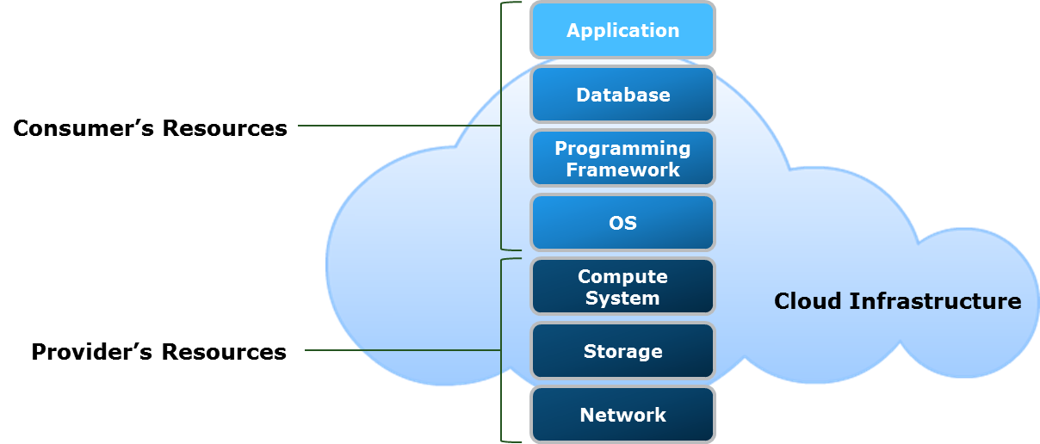

* Infrastructure as a Service (IaaS) model,

It provides the main computing services, like storage, processing security, and network organization, knowing that we as users allow us to access the applications we need and the operating systems we require without compromising the basic computing system.

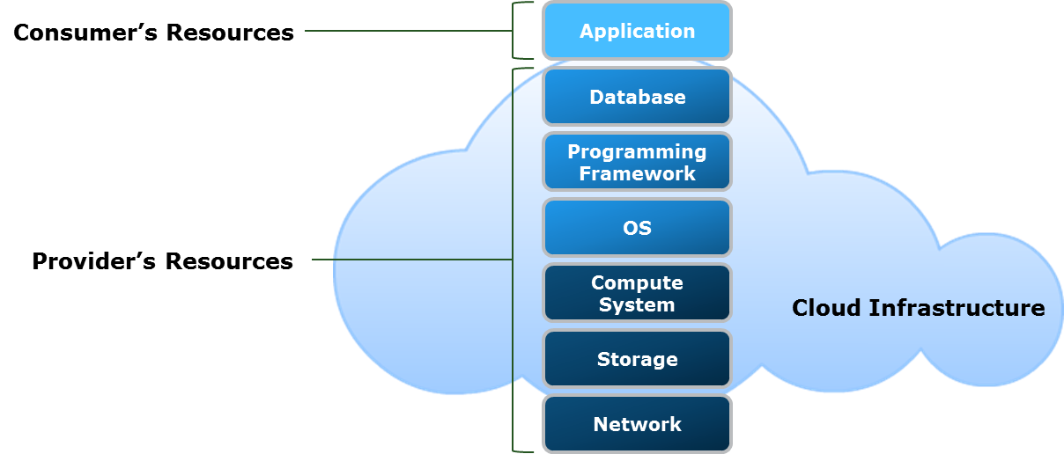

* In the Platform as a Service PaaS model,

Allowing users to start applications and work on expanding them and facilitating access to them by others. It also allows developers of these applications to test them in different working environments so that they can update them and then publish them. All of this is available in PaaS model.

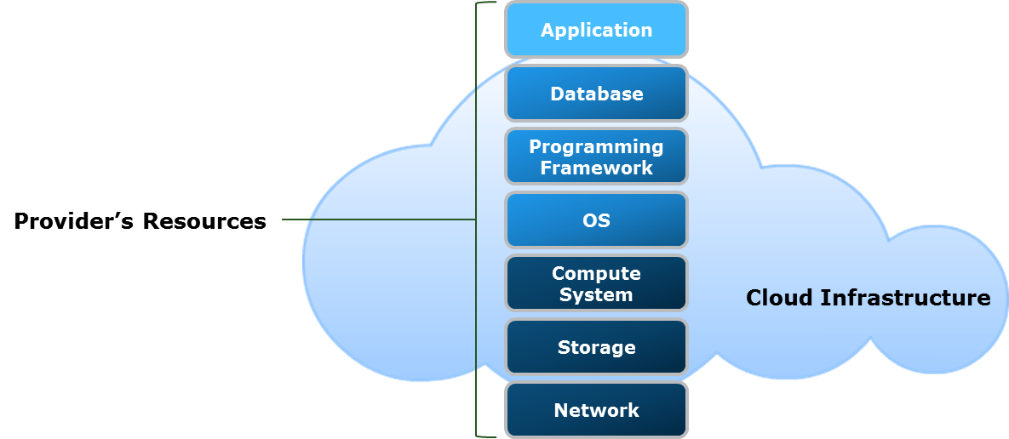

In the SaaS model, Providing the same service to multiple users, such as running the same application on different devices within a specific organization of sessions and requests, and this is done within the cloud without the need to install a specific application on users’ devices.[3]

***The most important companies dealing with cloud computing***

* Google Cloud Platform: It is considered the third largest company using cloud computing, providing users with storage services and allowing them to download and upload applications and develop on them.

### Amazon Web Services: If Google ranks third, then Amazon ranks first in the use of cloud computing, and it is also working to increase its use of computing while securing and documenting it to provide safe use for users.

### Microsoft Azure: Provides cloud computing services for downloading and publishing applications with a one-month free trial.[3]

### IBM Cloud: Availability of cloud computing services in its three different styles that we mentioned earlier, allowing its users to choose the appropriate style for their work.

### Oracle Cloud: It is owned by Oracle Cloud Infrastructure (OCI) and Oracle Cloud Software-as-a-Service (SaaS). It works to compete with other cloud service providers to provide the best services.

### VMware: It provides computing services with all its features and focuses on increasing profit and reducing costs.

***Disadvantages of cloud computing***

1. Cloud computing provides its services over the Internet and thus becomes out of service in the event of a malfunction or malfunction in the Internet network.
2. Cloud computing service provider stops service: This probability is very likely because cloud computing is recent. The more you rely on this provider, the greater the damage.
3. Security: We mentioned earlier that cloud computing is a secure system, but if it is not used appropriately by the user, like the user does not make good use of the digital security system of computing, security will turn from advantage to disadvantage. [4]

***Conclusion***

We also presented within this simplified research the concept of cloud computing and the importance it provides by providing resources and technology with good performance, reasonable prices and good speed, in addition to that it is constantly evolving and supporting its components continuously.

***References***

[1] Bradford, C. (2019). 7 Most Infamous Cloud Security Breaches – StorageCraft.

[2] Mell, P., & Grance, T. (2011). The NIST Definition of Cloud Computing.

[3] F L Tong, J Mao, R Bohn, J Messina, L Badger and D Leaf. (2011). NIST Cloud Computing Reference Architecture.

[4] Patrick, S. (2016). Security and the Cloud: Trends in Enterprise Cloud Computing Clutch.co.